**Guide for Test Generator**



**Version: 1.0**

**2018**

**Controls:**

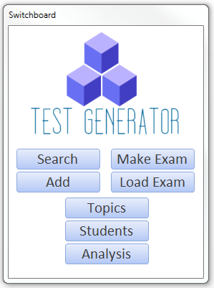

**Search –** Look through the database with the applied filters (3)

**Add –** Create a new question (4)

**Make Exam –** Create a new exam from questions in the database with specified requirements (5 - 6)

**Load Exam –** Print an existing exam and its corresponding answer key (7 - 8)

**Topics –** Edit or enable/disable a topic from future exams (9)

**Students –** Add or modify Students in the database (10)

**Analysis –** Tools for analyzing Student performance and trends (11-14)

**Search:**

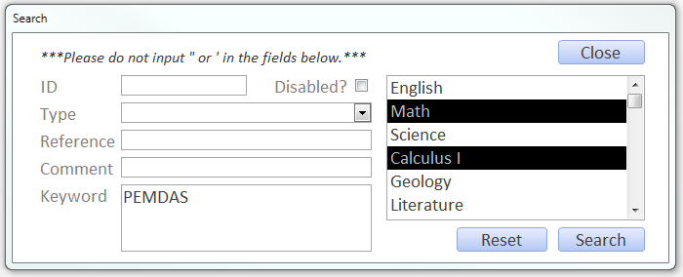

1. Input the information into this form to search for a matching question
   * ID – Unique identifier of the question.
   * Type – Type of question e.g. Multiple Choice or True/False.
   * Reference – The procedure or section of procedure the question is derived from.
   * Comment – Any note the user made on the question.
   * Keyword – Any part of the question text. Not case-sensitive.
   * Topic – Any topic the question falls under. May select multiple.

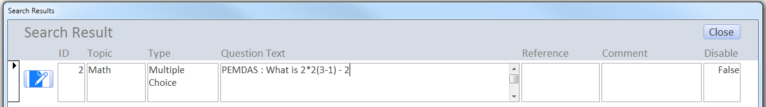

1. Upon filtering to find the question, click the  button to edit the question.

**Add:**

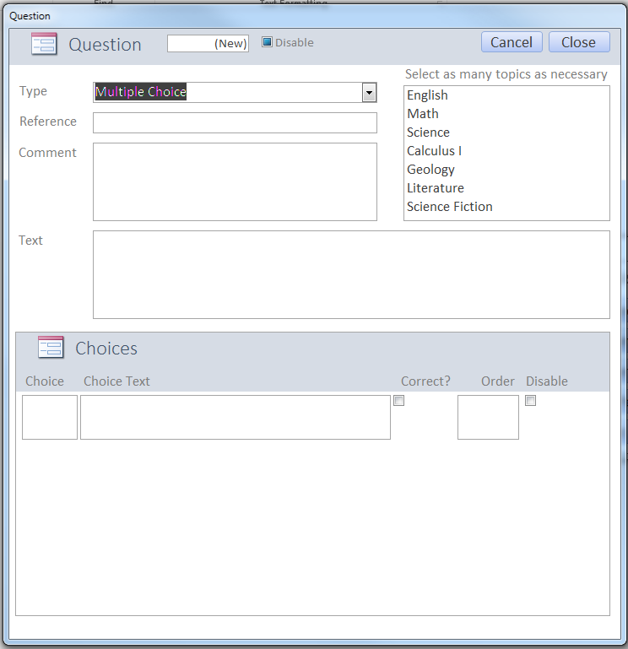

1. Create the question by typing the text in the corresponding fields.
2. Select the topic the question falls under. Multiple topics may be selected.
3. Create the answer choices for the question.
   * Choice – Letter of question e.g. A, B, C…
   * Choice Text – The text corresponding to the choice letter
   * Correct – Indicate if the corresponding choice is correct
   * Order – Specify ordering of choices
   * Disable – Prevents the choice from appearing on future exams

*** Upon closing, the question is auto-saved.

**Make Exam:**

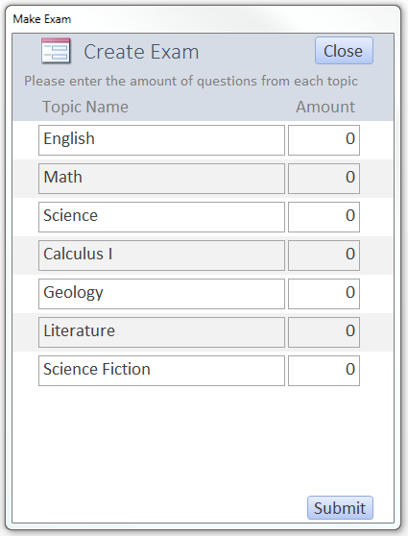

1. Create a new exam with random questions based on the number selected from each topic.
   * Must select at least one question
   * If there is less questions in the database than the number specified, all the questions from that topic will be pulled instead.

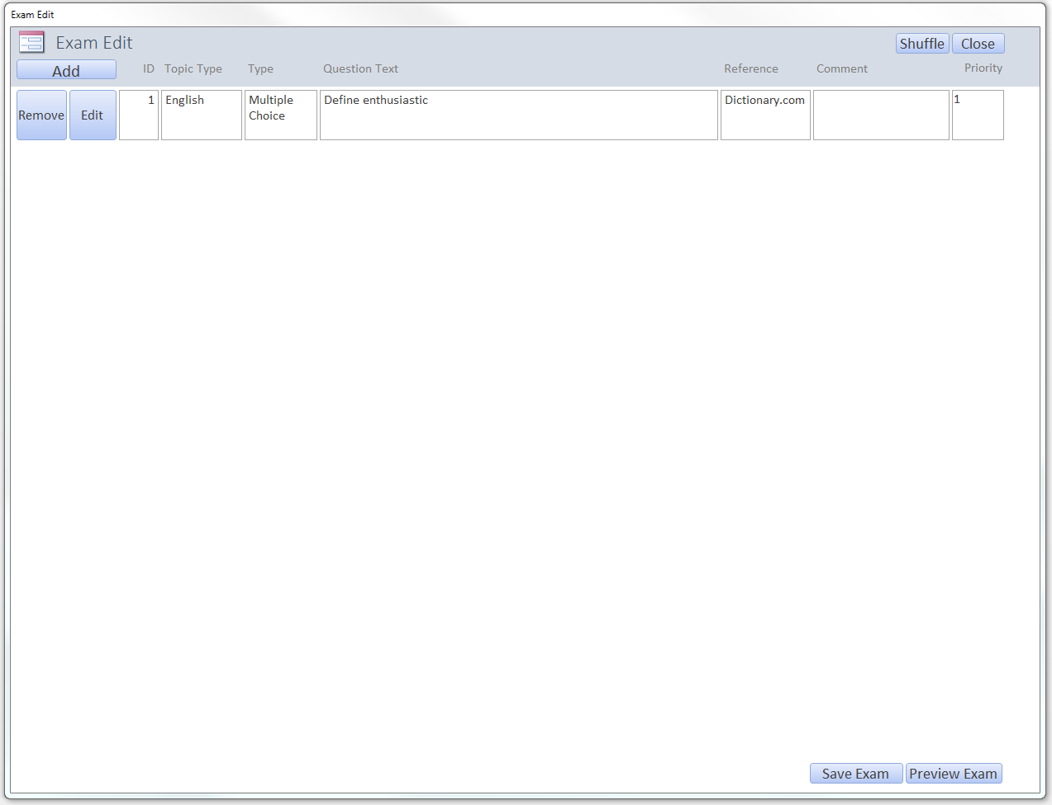

1. In the Exam Edit Environment:
   * Click *Add* to search and add a specified question to this exam.
   * *Remove* removes the question.
   * *Edit* allows the user to modify the question.
   * *Refresh* updates the screen to show changes.
   * *Preview Exam* creates a visual of the exam.
   * *Save Exam* saves the exam to the database. To print the answer key, the user must save the exam.
   * *Close ­*will clear this random pool of question and exit.

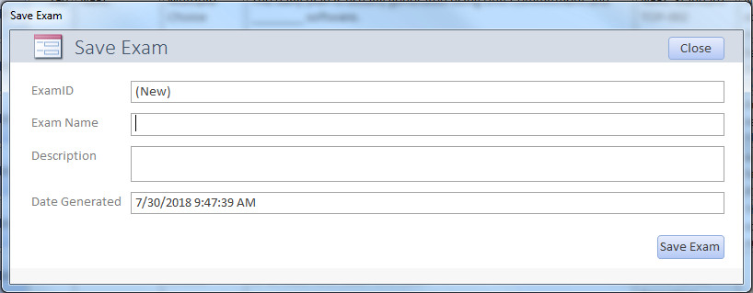

1. Name the exam and put a description if necessary and press *Save Exam.*

**Load Exam:**

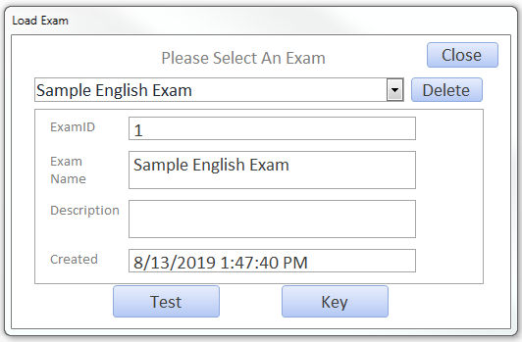

1. Select an exam by name from the dropdown.
2. Press *Test* to preview and print the exam.
3. Press *Key* to preview and print the answer key.
4. Press *Delete* to delete the selected exam.
   * Once an exam is deleted, the exam records for the corresponding exams will also be deleted.

**Sample Test:**

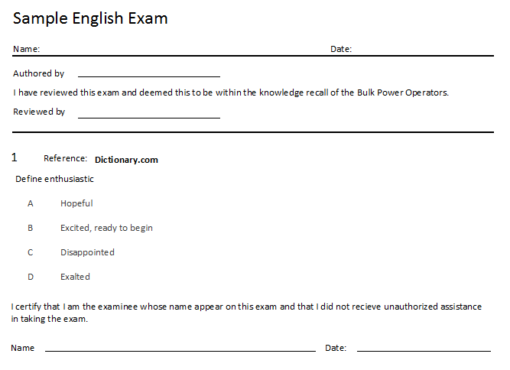

**Sample Key:**

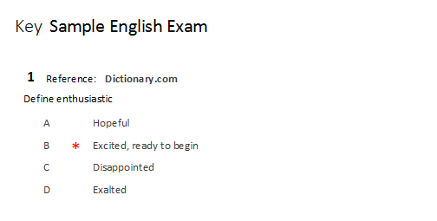

**Topics:**

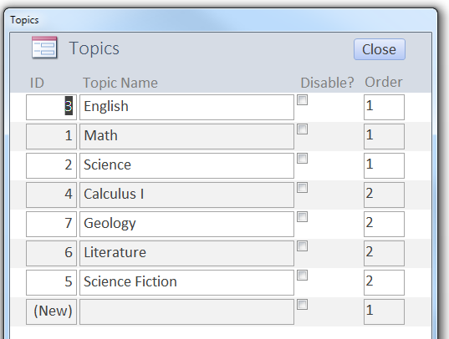

1. Add a new topic by selecting the blank textbox beside (New) and typing the name of the topic.
2. Enable/disable a topic by toggling the Disabled checkbox.
3. Order specifies the sequence for which the topics appear when searching for a question or making an exam by topic.
4. Close auto-saves and exits.

**Students:**

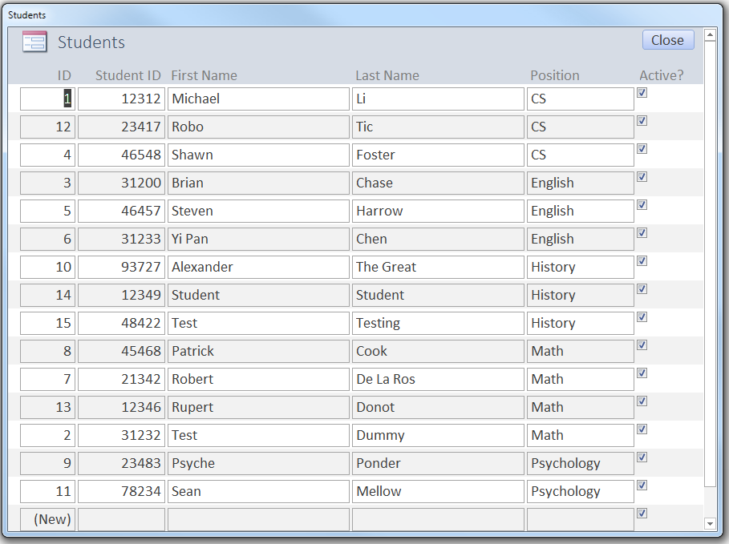

1. To create a new Student, type in data in the corresponding textboxes next to the (New).
2. To modify the information, select the textbox that would be changed and overwrite the information.
   * This can be done when a Student changes position, name or becomes inactive.
3. Close auto-saves and exits.

**Analysis:**

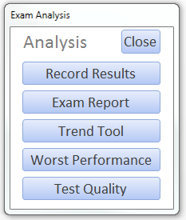

**Record Results –** Record a Student’s performance on an exam.

**Exam Report –** Analyze the overall performance of a Student and the rating of a topic for a specified exam.

**Trend Tool –** Opens Trend Tool for analysis.

**Worst Performance –** Select an exam and see the worst performance under a specified percentage

**Test Quality –** Select an exam and see the worst performance by question.

**Record Results:**

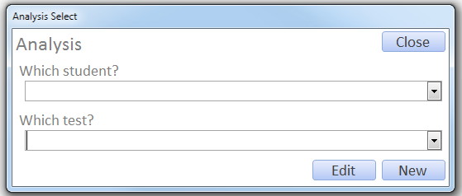

1. Select a Student and an exam. Press *Edit* to modify existing records. Press *New* to record new Student scores.

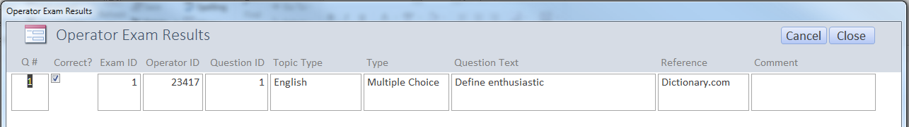

1. Toggle the *Correct?* checkbox to indicate whether the Student got the question correct or incorrect.
2. *Close* to auto-save and exit.

**Exam Report:**

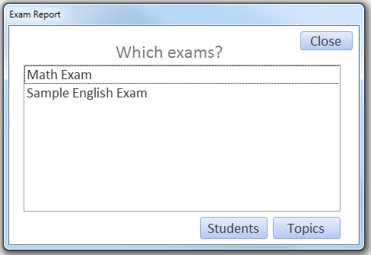

1. Select an exam. Press *Students* to see overall student scores. Press *Topics* to see performance by topic.

**Trend Tool:**

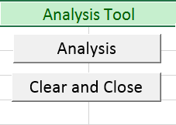

1. Click *Analysis* and the file will automatically create PivotCharts and PivotGraphs to enable you to see trends by student, trend by topic and trend by position.

**Worst Performance:**

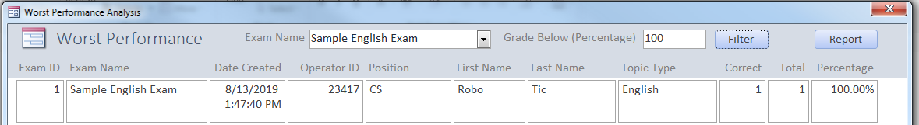

1. Select an exam and type in a percentage.
2. Press *Filter* to see the topics that need improvement.
   * Ordered by position, student, percentage
   * Additionally, clicking on the *First Name*, *Last* *Name*, *Topic* *Type*, and *Percentage* tabs will order the results correspondingly.
3. Press *Report* to preview and print a copy of the results displayed onscreen.

**Test Quality:**

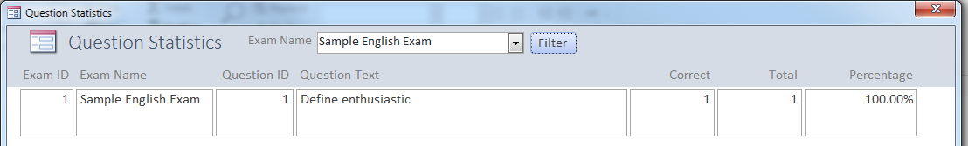

1. Select an exam and press *Filter* to see the statistics per question.

Questions?

Contact Michael Li

lim.michael.li99@gmail.com